**TtylProject Report Template**

1. **INTRODUCTION**
   1. Overview

Property management is the operation, control, and oversight of real estate properties. Its purpose is to ensure that the property is well-maintained, occupied by suitable tenants, and generates maximum income for the owner.

* 1. Purpose

**2 Problem Definition & Design Thinking**

2.1 Empathy Map



2.2 Ideation & Brainstorming Map

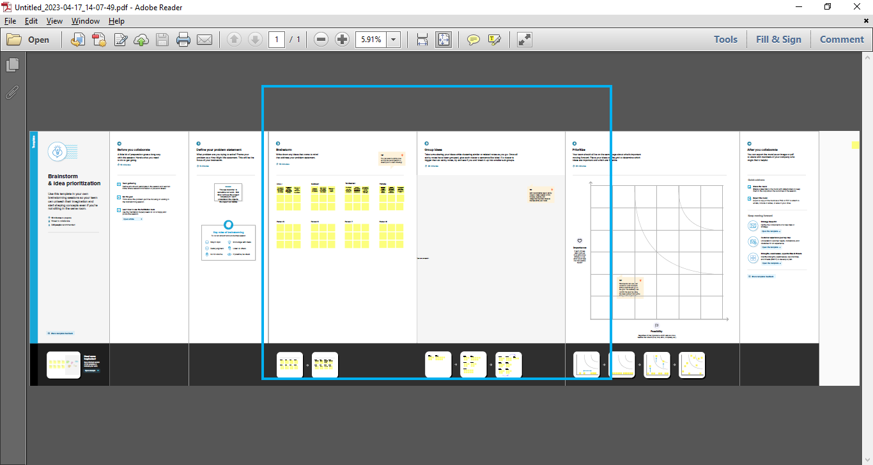

**3 Result**

3.1 data Model:

|  |  |
| --- | --- |
| Object Name | Fields in the object |
| Obj 1 | |  |  | | --- | --- | | Field Label | Data type | | Buy | None | | Rent | None | |
| Obj 2 | |  |  | | --- | --- | | Field Label | Data type | | Lead | Auto number | | State | Picklist | |

3.2 Activity & Screen shot

**4 Trailhead Profile Public URL**

Team Lead – <https://trailblazer.me/id>

Team Member 1-<https://trailblazer.me/id/ksundhar3>

Team Member 2-<https://trailblazer.me/id/kaphy>

Team Member 3-<https://trailblazer.me/id/ppraveen86>

**5 ADVANTAGES & DISADVANTAGE**

ADVANTAGES

**Time-saving:** Property managers handle all the administrative and maintenance tasks associated with owning rental property, freeing up the owner's time.

**Tenant screening:** Property managers have systems in place for finding and vetting suitable tenants, which can greatly reduce the risk of problematic tenants.

**Rent collection:** Property managers handle rent collection, which can be a challenging and uncomfortable task for some property owners.

**Property maintenance**: Property managers take care of routine maintenance and repairs, ensuring that the property is kept in good condition.

DISADVANTAGE

**Cost:** Property management services can be expensive, with fees ranging from 5% to 10% of the monthly rent, plus additional fees for vacancy advertising and maintenance.

**Loss of control:** Property owners may feel that they are losing control over their property when hiring a property manager.

**Quality of services**: Property owners may be concerned about the quality of services provided by the property manager.

**6 APPLICATIONS**

Applications of property management are wide-ranging, including commercial property management, residential property management, retail property management, and industrial property management.

**7 CONCLUSION**

In conclusion, property management is an essential service for many property owners, helping to ensure that their properties are well-maintained, efficiently managed, and generate maximum income. Despite the disadvantages, the advantages of property management make it a valuable investment for many property owners.

**8 FUTURE SCOPE**

Future scope of property management is promising, with technology and automation transforming the industry. Property managers are increasingly using software and artificial intelligence to streamline their operations and provide better services to their clients. As the demand for rental properties continues to grow, the need for property management services will only increase in the future.